

**Workplace Relationships: The new normal requires them to be both strong and weak**

* Published on September 6, 2020
* [**Edit article**](https://www.linkedin.com/post/edit/6708356214868242432)
* [**View stats**](https://www.linkedin.com/pulse/workplace-relationships-new-normal-requires-them-both-dan-lindner/ca/post-analytics/urn:li:linkedInArticle:6708356214868242432/?trackingId=fFnPGFL5Sy2bOIZomCJOtA%3D%3D)

**[[](https://www.linkedin.com/in/dan-lindner-cfp-cebs/)](https://www.linkedin.com/in/dan-lindner-cfp-cebs/)**

**[Status is online](https://www.linkedin.com/in/dan-lindner-cfp-cebs/)**

**[Dan Lindner](https://www.linkedin.com/in/dan-lindner-cfp-cebs/)**

Communications, Culture & Engagement Strategist

What do workplace relationships have in common with employee engagement and the sharing economy? Everything; and now more than ever with the rapid and large-scale changes forced by covid-19.

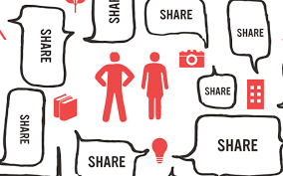

Relationships and employee engagement reside at opposite ends of a continuum, with alignment and trust making up the remaining elements in the sequence. There are no short cuts. World-class employee engagement requires a rich, diverse network of relationships – a community where individuality, autonomy, and creativity can flourish at scale. In the sharing economy, networked employees connect through a platform.

We’ve all seen the data; companies with engaged employees consistently outperform the competition, and yet only one-third of US workers are engaged. What’s more, studies show that only 5% of workers strongly agree that their organization helps them build strong relationships. These results do not belong on the resume of companies that spend exorbitant amounts on employee engagement each year.

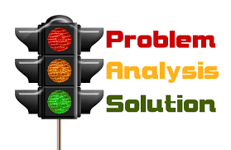

A Gallup study reveals that 70% of the variance in employee engagement is dependent on front-line managers. In most large organizations, the responsibility is scattered across HR, Marketing, and IT. After all, engagement reflects the relationship that employees have with the company. More eyes on the problem, right? However, as the number of stakeholders increase, so does the diversity of goals, assumptions, meanings, and fragmented opinions about the problem and range of solutions. As a result, cracking the disengagement code has morphed into a high-stakes game of whack-a-mole. The issue isn’t whose fault the mess is, it’s our collective failure to recognize the recurring and inevitable dynamics of the mess. It is a wicked problem that requires a design-thinking approach to solve.

There is a consensus among practitioners that all engaged workers are happy, but happy workers are not necessarily engaged. But what does happiness and engagement have in common? Neither is a solvable equation; there’s no finish line per se, as each is predicated on solving problems that are constantly changing and evolving. The optimal state is quite fluid, where meaning and purpose is achieved by making progress with, or improving the quality of, our problems. In the post-modern world, problem-solving is inherently social. That is to say, getting something done depends on our social skills and network – both formal and informal.

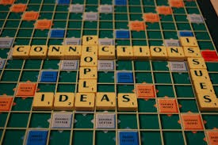

Managers and teammates are part of a cohort collectively known as strong ties; people with whom we have a deep affinity. The importance of strong ties cannot be overstated, as they cohesively tie together closely knit groups. Weak ties, in contrast, might be acquaintances, or strangers with a common background, interest, purpose or passion, but who often possess knowledge and perspectives different from our strong ties.



Whereas strong ties are relatively few in number, weak ties can scale connections and relationships up to the size of the enterprise. In terms of information networks, weak ties are most effective in accessing unique information and knowledge due to their structural ability to connect different parts of the network. A vast network of weak ties provides the greatest potential to positively affect problem-solving, learning, communications, collaboration, innovation, knowledge-sharing, and business outcomes. As a result, these connections help to improve the quality of our problems and thus, employee engagement.



The disruption caused by Covid-19 cannot be overstated, as virtually every organization is operating on a mandatory WFH.  Internet connections are the main lifeline to our work lives. It’s as isolating for many as it is liberating for others, and is less social, more siloed, and disconnected than most are prepared for.  To be sure, there are synergies unique to office environments that make them vital to organizational health. They will continue to thrive post-covid – albeit more physically distanced than we’re accustomed.

By the same token, remote work is here to stay.  Our increasingly distributed workforce needs a networked community of vibrant weak ties to operate effectively while sustaining corporate cultures that have been rattled by the pandemic. Whereas a robust digital support structure is already in place in our personal social networks, it’s almost completely out of context for the workplace just when we need it the most. It is a shortcoming of our own making, due to traditional hierarchies, outdated tools, and organizational inertia. Until now, we’ve been able to lean on our legacy physical skills and environments.

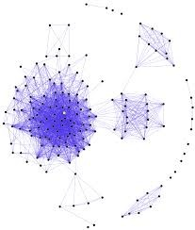

Most workers desperately need the resilient and vibrant connective tissue of an enterprise network that enables relationships between far flung weak ties, access to groups of experts, reams of searchable open knowledge, and the deep insight that can augment or step in for the loss of our physical world of work.

For leaders, it’s time to put your organization on a modern digital platform that is resilient in the face of disruption, and taps into collective wisdom of a hyper-charged mass of networked employees who think and act like intrepreneurs. Companies with the healthiest, best connected, and digitally engaged network of workers will experience the least disarray and breakdown when major events like covid-19 take place. The future of work is community-based, and the future is now.  I’d love to hear your thoughts.